de Gucena 2018-01875

Feature Activity 04 Documentation

Getting Started



Finding images

Tagging images

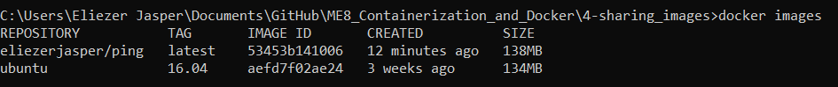

Pushing images

